Title I, Part A Allocation Process
Madison Metropolitan School District

Distribution of Title I Funds

Title I, Part A funds are targeted to high-poverty school districts and provide supplemental services to students who are educationally disadvantaged or at risk of failing to meet the state academic standards. A state administered program, Title I funds are distributed by the United States Department of Education (USDE) to the Wisconsin Department of Public Instruction (DPI.) DPI distributes the funds to school districts by using a complex funding formula defined in law and based on census poverty data or Small Area Income Percentage Estimate (SAIPE) data in non-census years. School districts must then determine which of their schools are eligible to receive this funding.

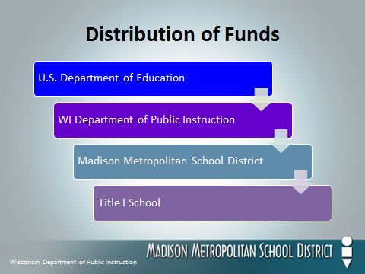
Title I School Eligibility

Madison Metropolitan School District (MMSD) schools become Title I eligible when they meet or exceed the district poverty average. In the past, this was determined through the numbers of students age 5-17 receiving free and reduced lunch as reported on the 2nd Friday count date in January. This year, it was noticed that schools implementing the Community Eligibility Provision (those that provide free meals to all their students) were not receiving the same amount of free / reduced lunch applications as seen in previous years. This raised the concern that Title I school eligibility would not be based on accurate reflections of poverty. DPI heard the same concern from many CEP districts across the state. They guided MMSD and other districts implementing CEP to utilize direct certification counts when determining the district poverty average for 2016-17 Title I school eligibility. These numbers are provided by DPI and include students who automatically receive free lunch for a variety of reasons. When using this data, all schools still experienced Title I eligibility trends very similar to what was observed in previous years.
Title I Reservations

All districts receiving Title I funding have the opportunity to utilize a small portion of the allocation for district-wide Title I initiatives. These funds are taken in the form of “reservations” that can only be used for certain expenditures as defined in law. In MMSD, reservations are taken in the area of administration, centralized services, parent involvement, homelessness, and migrant education. Important to note, any reservations taken must be utilized in a way that aligns with district needs assessment data while directly supporting Title I initiatives only. Non-Title I schools may not benefit from Title I reservation funds except in the areas of homelessness and migrant education.

Title I School Budgets

Once schools are determined eligible, they must be served with Title I funds in rank-order of poverty from highest to lowest. Once this rank order is established, a per pupil amount is determined for each eligible school. MMSD utilizes a tiered model approach, assigning higher per pupil amounts to schools with more intensive needs as determined by poverty levels and other measurable data. Important to note, schools with higher poverty must have equal or higher per pupil amounts than those with lower poverty. To calculate the Title I budget for each eligible school, one would multiply the per pupil amount by the number of directly certified students in that particular school.

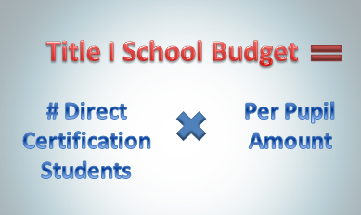
Use of Title I Funding

Title I is distributed through an entitlement grant meaning that these are formula-driven, non-competitive funds that MMSD receives on an annual basis through an application process. Since the amount of Title I funding is driven by measures of poverty across the state and nation, there is no way to predict what award amounts will be from year to year. Additionally, changes in low-income enrollment within schools and across the district can also result in increases or decreases in Title I funds at the school level. Therefore, and by law, Title I funding should always be utilized in a way that supplements local district support.

